1. Write a C program to implement Bresenham line drawing algorithm.

Enter co-ordinates of first point: 70 80

Enter co-ordinates of second point: 225 160

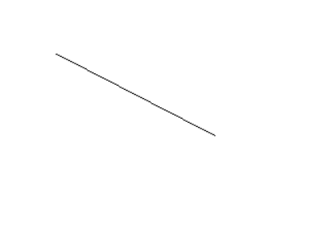

1. Write a C program to implement DDA line drawing algorithm.

Enter start co-ordinate (x1,y1): 150 90

Enter END co-ordinate (x2,y2): 150 320

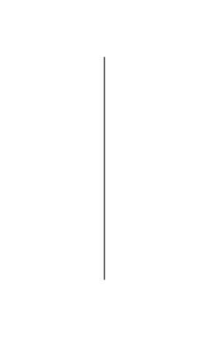

1. Write a C program to implement Mid-Point line drawing algorithm.

Enter co-ordinates of first point: 30 45

Enter co-ordinates of second point: 200 7

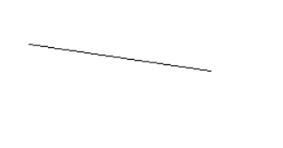

1. Write a C program to implement Bresenham circle drawing algorithm.

Enter the radious : 120

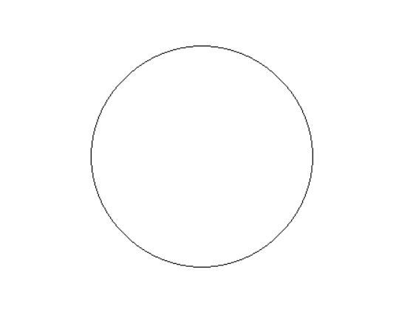

1. Write a C program to implement Mid-Point circle drawing algorithm.

Enter radius of circle: 50 -60

Enter co-ordinates of center(x and y): 100

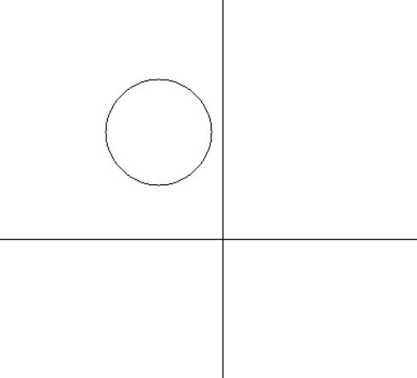

1. Write a C program to implement 2D shearing in X-axis.

please enter first coordinate = 50 40

please enter second coordinate = 110 160

please enter third coordinate = 160 80

please enter shearing factor x = 2

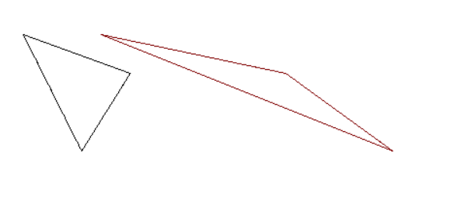

1. Write a C program to implement 2D shearing in Y-axis.

please enter first coordinate = 50 25

please enter second coordinate = 60 125

please enter third coordinate = 160 50

please enter shearing factor x = 2

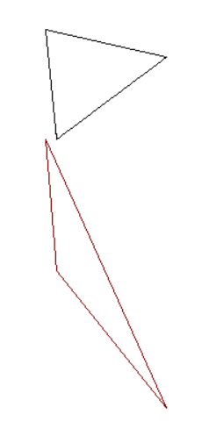

1. Write a C program to implement 2D reflection in X-axis.

Enter the coordinates of triangle

-----------------------------------------

(x1,y1) = 30 42

(x2,y2) = 180 160

(x3,y3) = 220 80

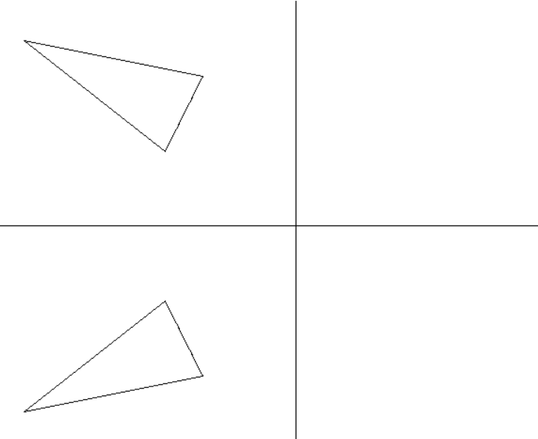

1. Write a C program to implement 2D reflection in Y-axis.

Enter the coordinates of triangle

-----------------------------------------

(x1,y1) = 50 30

(x2,y2) = 30 160

(x3,y3) = 180 100

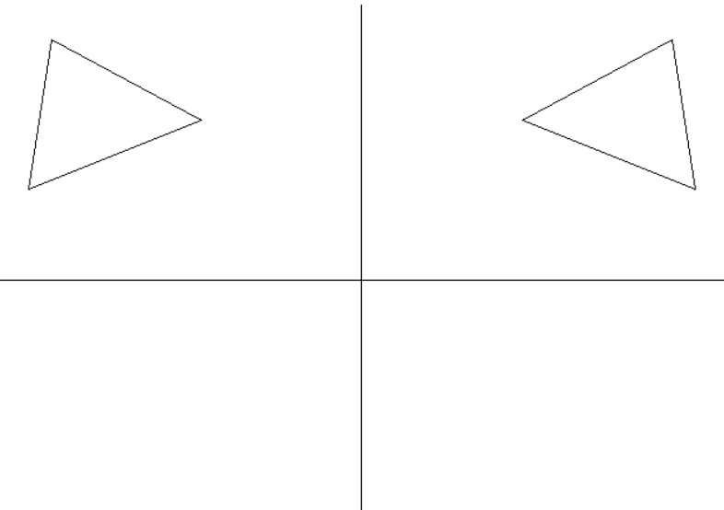

1. Write a C program to implement 2D scaling.

Enter scaling factor sx & sy: 120 80

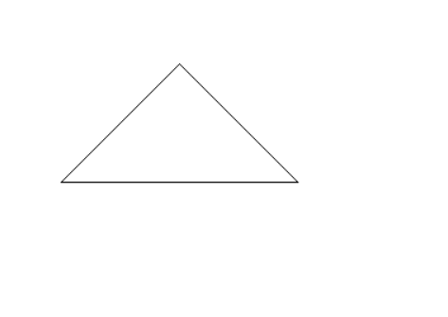

1. Write a C program to implement 2D rotation.

Enter the 1st point for the triangle : 35 45

Enter the 2nd point for the triangle : 120 100

Enter the 3rd point for the triangle : 160 80

Enter the angle for rotation:60

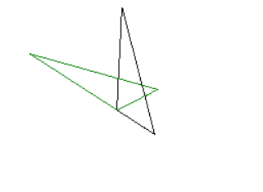

1. Write a C program to implement 2D translation

Enter the initial and final coordinates of a line :

(x0 and y0) = 50 60

(x1 and y1) = 200 60

